CURRICULUM VITAE

BALAEVA MANZURAMO TAGHAIMURODOVNA
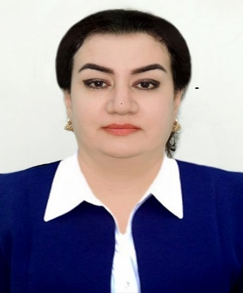

*SinceAugust 2006, she hasbeenworkingasthe deputy generaldirectorfor scientific affairsoftheStateInstitution "RepublicanComplexofKulobMuseums".

*Year of birth: November 18, 1975.
*Place of birth: Kulob city.
*Nationality: Tajik.
*Education:Higher.Graduated from Kulob State Institute in 1997.
*Specialization:English teacher and translator.
*Scientific degrees:Does not have.
*What foreign languages ​​do you know: Russian, English.
*Whether she is a representative of the people or not: Not.
*Awarded with state awards or not: Not.
*Party:Not
*Marital status: - Married, has three children.
*Address: Kulob city, H. Nemat Str 5/17, telephone985-18-11-75
*Email: balaeva_manzura@mail.ru

Workexperience:

 | Years  From what time  to what |  |  | Position indicating the name of government bodies, enterprises, institutions and other organizations
From1992 to 1997  FromMay 1994 to  August 1994  From June 1996 to November 1997  From December 1997  To September 1999 |  |  | Student of Kulob State Institute.  Secretary, Sano Canada Joint Venture, in Kulob city, Tajikistan  Data entry clerk, Save the Children / US, inVose district, Tajikistan  Secretary,Tajik Turk High School in Kulob city, Tajikistan
From October 1999 to June 2002  From July 2002  toSeptember 2006  From October 2006 to December 2010  From January 2011 to June 2021 |  |  | Translator, Children Aid Direct / England in Kulob city, Tajikistan  Admin / Finance Officer,Action Against Hunger / USA in Kulob city,Tajikistan  Finance/Admin Assistant, AKHS in Khatlon Region, in Kulob city, Tajikistan  Admin / Finance Officer,AKHS in Khatlon Region, in Kulob city, Tajikistan

